Mystery Matrix
If you fill in the spaces in the first of these two table squares (or matrices) you get the second one.
Can you see how it is done?
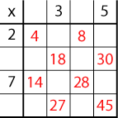
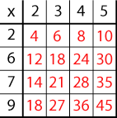

You will notice that the numbers 2 - 9 are used to generate the matrix and only one of these numbers is used twice (the 2).
Can you fill in the matrix (table square) below? The numbers 2 -12 were used to generate it with, again, just one number used twice.

